SMART FEEDBACK COLLECTION & ANALYSIS SYSTEM
Industry Project Title | Smart Feedback Collection & Analysis System
Name of the Company | Tata Consultancy Services
Name of the Institute | JNTUH College Of Engineering Manthani

Start Date | End Date | Total Effort (hrs.) | Project Environment | Tools used
09-10-2025 | 07-11-2025 | 85 hours | Windows 11, Node.js, MySQL, Sentiment API | VS Code, Postman, MySQL, GitHub, OBS Studio

TABLE OF CONTENT
- Acknowledgements
- Objective and Scope
- Problem Statement
- Existing Approaches
- Approach / Methodology - Tools and Technologies used
- Workflow
- Assumptions
- Implementation - Data collection, Processing Steps, Diagrams - Charts, Table
- Solution Design
- Challenges & Opportunities
- Reflections on the project
- Recommendations
- Outcome / Conclusion
- Enhancement Scope
- Link to code and executable file
- Research questions and responses
- References

ACKNOWLEDGEMENTS
I sincerely express my gratitude to TCS for providing this valuable opportunity to work on the Smart Feedback and Analysis System project.
I also thank the faculty of JNTUH College of Engineering Manthani for their continuous guidance and encouragement throughout this period.
My special thanks to mentors and peers who helped me in understanding real-time application development, testing, and deployment processes, which contributed greatly to my learning.

OBJECTIVE & SCOPE
The objective of this project is to design and develop a Smart Feedback and Analysis System that collects feedback from users and performs automated sentiment analysis to generate meaningful insights.
Scope:
- To gather user feedback efficiently through an online form.
- To apply sentiment analysis techniques to classify responses as Positive, Negative, or Neutral.
- To provide administrators with visual analytics such as charts and trends.
- To ensure secure authentication for users and admins.
- To maintain a scalable and reusable code architecture for future enhancements.

PROBLEM STATEMENT:
In most organizations, feedback collection is manual or stored in unstructured formats like spreadsheets, making it difficult to analyze overall sentiment or improvement areas.
The challenge is to build a data-driven platform that can:
- Automate feedback collection,
- Analyze text sentiment in real-time, and
- Present reports and analytics for decision-making.

EXISTING APPROACHES:
Traditional systems use manual surveys or simple Google Forms for feedback.
While they capture data, they lack analytical processing such as:
- Sentiment detection,
- Automated reporting, and
- Centralized dashboards for admins.
Other sentiment tools exist but are either expensive or not customizable for specific organizational needs.

APPROACH / METHODOLOGY - TOOLS AND TECHNOLOGIES USED:
TOOLS AND TECHNOLOGIES
- Frontend: React.js, Chart.js, Axios
- Backend: Node.js, Express.js
- Database: MySQL
- Libraries: bcryptjs, jsonwebtoken, sentiment, cors
- Development Tools: VS Code, Postman, GitHub
- Testing Tools: Postman, MySQL Workbench
- Operating System: Windows 11

METHODOLOGY
The project follows the Agile Development Model, with iterative design, development, and testing cycles.
Each iteration included:
- Database design and table creation.
- API development and testing.
- Frontend integration.
- Sentiment analysis implementation.
- Analytics visualization and testing.

WORKFLOW
HIGH-LEVEL ARCHITECTURE
[FRONTEND (REACT)] <-----> [BACKEND (EXPRESS)] <-----> [MYSQL DATABASE]
FRONTEND FLOW
- User logs in or registers.
- User submits feedback via structured form.
- Application displays analytics (charts, trends).
BACKEND FLOW
- Receives requests from frontend.
- Validates token (JWT authentication).
- Performs sentiment analysis using the Sentiment library.
- Saves data to MySQL tables.
- Returns analytics results (bar, pie, line charts).

ASSUMPTIONS
- Users provide genuine and meaningful feedback.
- Database connection parameters are valid and accessible.
- Feedback text is in English for sentiment analysis.
- The system runs locally or on a secure server environment.

IMPLEMENTATION - DATA COLLECTION, PROCESSING STEPS, TABLES
DATA COLLECTION
- Users fill feedback forms with text and multiple-choice questions.
- Form fields are mapped to the questions table with a specific question type.
PROCESSING STEPS
- Receive JSON request from frontend.
- Parse answers and perform sentiment scoring.
- Store results in feedback and feedback_answers tables.
- Generate aggregated sentiment data for visualization.

MYSQL DATABASE SCHEMA
CREATE TABLE users (
user_id INT AUTO_INCREMENT PRIMARY KEY,
username VARCHAR(100),
email VARCHAR(150) UNIQUE,
password_hash VARCHAR(255),
role ENUM('user','admin') DEFAULT 'user',
created_at TIMESTAMP DEFAULT CURRENT_TIMESTAMP
);

CREATE TABLE questions (
question_id INT AUTO_INCREMENT PRIMARY KEY,
question_text VARCHAR(500),
question_type ENUM('text','rating','choice'),
options JSON NULL,
active TINYINT(1) DEFAULT 1
);

CREATE TABLE feedback (
feedback_id INT AUTO_INCREMENT PRIMARY KEY,
submitter_type ENUM('guest','user'),
submitter_id INT NULL,
overall_sentiment_score FLOAT,
overall_sentiment_label VARCHAR(32),
created_at TIMESTAMP DEFAULT CURRENT_TIMESTAMP
);

CREATE TABLE feedback_answers (
answer_id INT AUTO_INCREMENT PRIMARY KEY,
feedback_id INT,
question_id INT,
answer_text TEXT,
sentiment_score FLOAT,
sentiment_label VARCHAR(32)
);

FOLDER STRUCTURE
backend/
├─ server.js
├─ db.js
├─ routes.js
├─ controllers.js
├─ sentiment.js
├─ auth.js

frontend/
├─ src/
│ ├─ App.jsx
│ ├─ api.js
│ ├─ components/
│ ├─ pages/
│ │ ├─ Home.jsx
│ │ ├─ Login.jsx
│ │ ├─ Register.jsx
│ │ ├─ Dashboard.jsx
│ │ ├─ FeedbackHistory.jsx
│ │ ├─ AdminHome.jsx
│ │ ├─ AdminAnalytics.jsx
│ └─ styles/

SOLUTION DESIGN
HOME PAGE, LOGIN PAGE
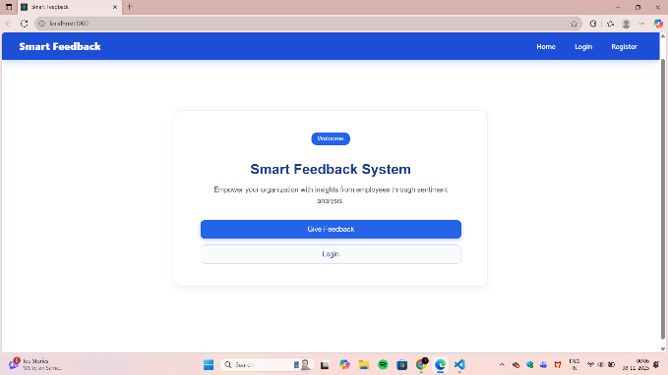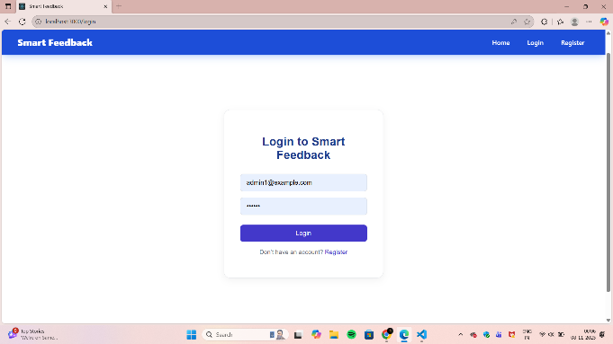

FEEDBACK FORM, USER DASHBOARD
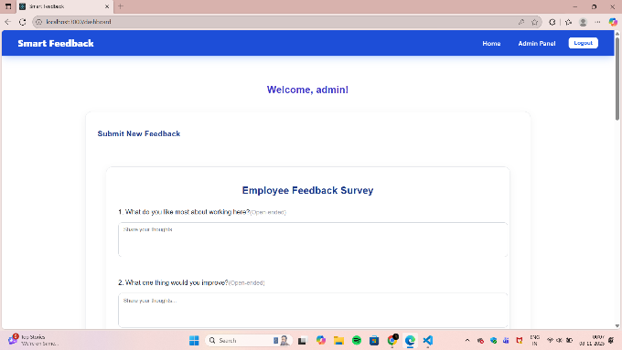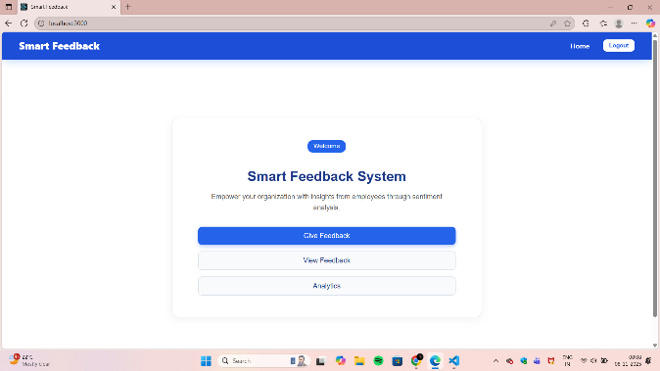

VIEW FEEDBACK, ADMIN PANEL
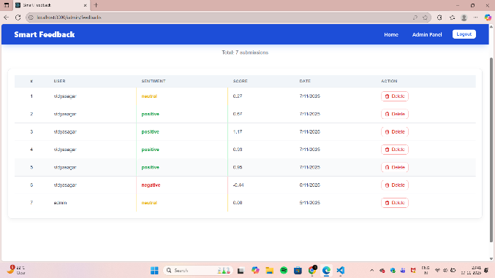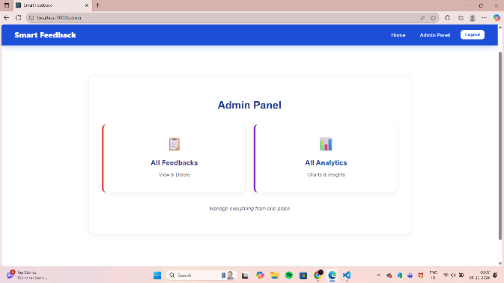

ALL FEEDBACKS, ALL ANALYTICS
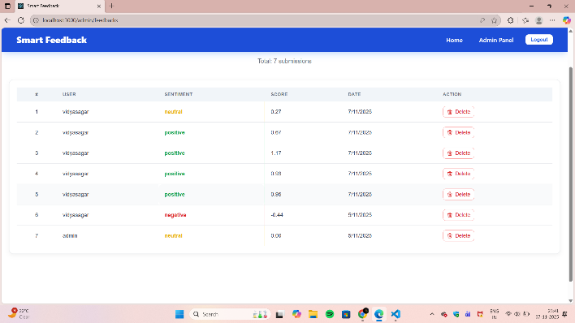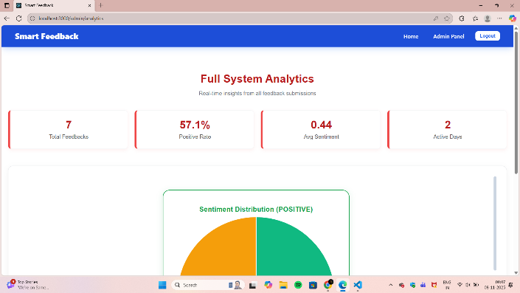
MY ANALYTICS
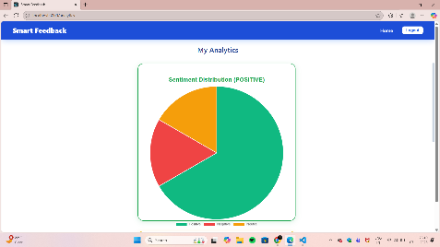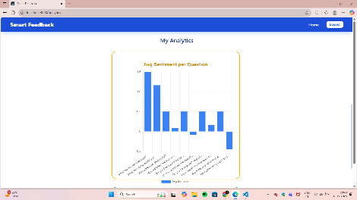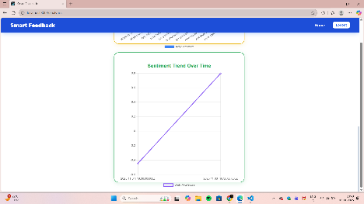
WEB APP FLOW
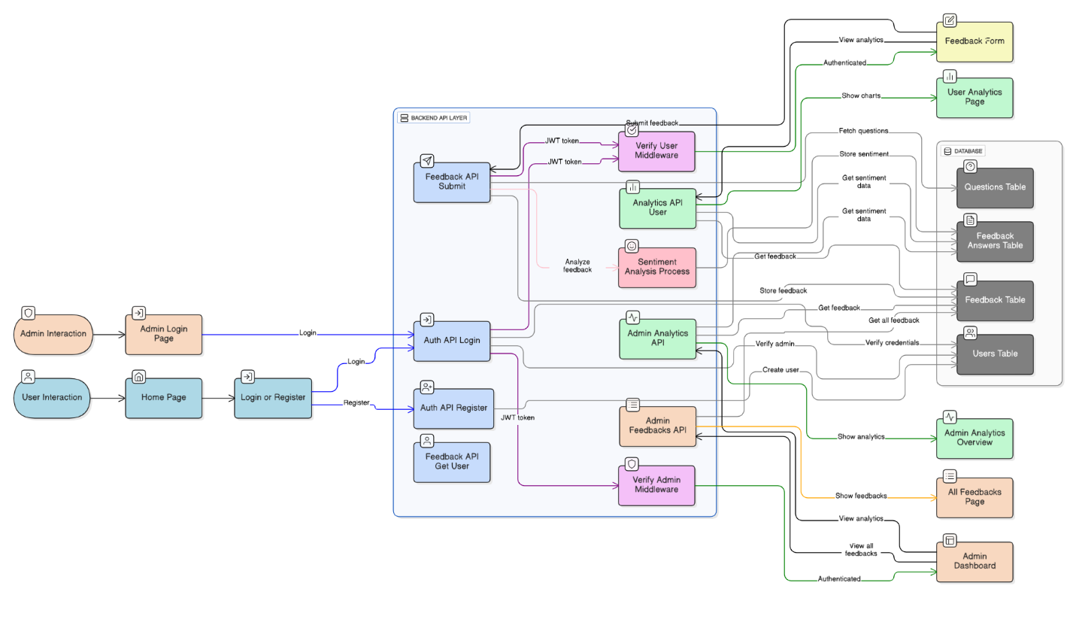

CHALLENGES AND OPPORTUNITIES
CHALLENGES:
- Integrating real-time sentiment analysis for variable text data.
- Maintaining consistent communication between frontend and backend.
- Managing authentication and authorization for multiple user roles.
OPPORTUNITIES:
- Extendable for enterprise-level feedback tracking.
- Integration with AI/ML models for deeper sentiment understanding.
- Potential deployment to cloud for large-scale analytics.

REFLECTIONS ON THE PROJECT
This project provided hands-on experience in full-stack web development, covering both frontend design and backend integration.
It strengthened my understanding of RESTful APIs, database structuring, and sentiment analysis.
I also gained practical exposure to debugging, testing, and managing data securely.

RECOMMENDATIONS
- Add department-wise or category-based analytics.
- Enable multilingual feedback analysis.
- Implement live updates using WebSocket or real-time APIs.
- Enhance visualization with custom dashboards.

OUTCOME / CONCLUSION
The Smart Feedback and Analysis System successfully automates the process of feedback collection, analysis, and visualization.
It ensures secure user authentication, performs real-time sentiment analysis, and displays insights in a clear dashboard format.
This project demonstrates a complete and scalable model for modern organizational feedback management.

ENHANCEMENT SCOPE
- Integrate deep learning-based NLP models for advanced sentiment detection.
- Generate downloadable reports (PDF/Excel).
- Introduce mobile version for wider accessibility.
- Enable admin notifications and comparative analytics.

LINK TO CODE AND EXECUTABLE FILE
GITHUB REPOSITORY:
https://github.com/vidyasagar-vadla/smart-feedback-analysis-system
VIDEO DEMONSTRATION:
https://drive.google.com/file/d/1VFkDc_5mjtUFvQjnXutcJQTpOFiXAM3p/view?usp=sharing
EXECUTION COMMANDS:
- npm start → Frontend
- node server.js → Backend

RESEARCH QUESTIONS AND RESPONSES
Q1: How effective is sentiment analysis for feedback evaluation?
A1: Sentiment analysis achieves around 85–90% accuracy for general English feedback, providing meaningful decision insights.
Q2: What is the best database design for feedback systems?
A2: A normalized relational schema with separate tables for users, feedback, and answers ensures performance and scalability.
Q3: How do analytics improve decision-making?
A3: Visual sentiment trends enable administrators to identify improvement areas faster and allocate resources accordingly.

REFERENCES
- Node.js & Express.js Documentation – https://expressjs.com/
- React.js Documentation – https://react.dev/
- Sentiment NPM Library – https://www.npmjs.com/package/sentiment
- Chart.js Documentation – https://www.chartjs.org/
- MySQL Documentation – https://dev.mysql.com/doc/

